General Pay Equity FAQs
What is pay equity?
Pay equity is about the same pay for doing jobs that are different but are of equal value. It recognises that while on the surface two jobs may look very different to each other, they require the same or similar degrees of skills, responsibility, conditions, experience, and effort.
Pay equity acknowledges that female-dominated occupations may have experienced perceptions and prejudices that have led to sex-based undervaluation of the work. In brief, pay equity is about correcting sex-based undervaluation of female-dominated workforces.
What’s the difference between pay equity and equal pay?
‘Equal pay’ generally refers to men and women receiving the same pay for doing the same job. ‘Pay equity’ is about men and women receiving the same pay for doing work that is of equal value.
What claims have been made in DHBs?
Unions have raised pay equity claims for roles within the following workforces:
- Nursing – New Zealand Nurses Organisation (NZNO) and Public Service Association (PSA).
- Administration and Clerical – Public Service Association (PSA).
- Midwifery – Midwifery Employee Representation and Advocacy Service (MERAS) and New Zealand Nurses Organisation (NZNO).
- Allied, Scientific and Technical – Public Service Association (PSA) and Association of Professional and Executive Employees (APEX).
What is the process for addressing a pay equity claim?
There are three key stages to the pay equity process:
- Raising a claim.
- Assessing a claim – the Allied, Scientific and Technical is at this stage.
- Settling a claim – the Midwifery claim is at the beginning of this stage, and the Nursing and Administration and Clerical claims are at this stage.
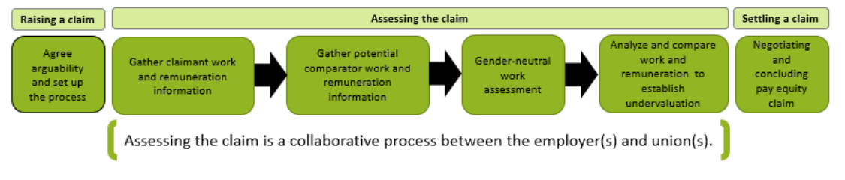
Assessing the claim involves the DHBs and unions gaining a good understanding of the claimant work and the work of male-dominated potential comparator roles.
The DHBs and the union together select a representative sample of the workforce and talk to the employees and their supervisors to learn more about the work they are doing, including their skills, responsibilities, working conditions and demands.
A comparator is a person who is doing work that may be of a similar value but in a role that is mostly performed by men. We look at what skills, demands and responsibilities are needed for the comparator roles and look at their working conditions to establish if the work is comparable.
If the work is comparable, the remuneration of both claimants and comparators is analysed and assessed. The purpose of this is to find out whether the claimant is being paid less than the comparator because of their sex. If there is sex-based undervaluation, the parties will negotiate a settlement.
How are the roles compared?
We use a work assessment tool designed to be gender-neutral, capturing all relevant information about jobs, including skills, knowledge, responsibility and working conditions, that may have traditionally been overlooked. The tool considers the following aspects of the work:
- Skill: knowledge, problem-solving, interpersonal, physical skills.
- Responsibilities: responsibilities for leadership, resources, organisational outcomes, services to people.
- Demands: emotional, sensory and physical demands, and working conditions.
The work does not need to be from the same industry. Pay equity is about comparing the value of work, even where that work is different.
What male-dominated roles were used as comparators?
The details of the comparators will be included in the full proposed settlement agreement that will be circulated before ratification.
I am a DHB employee – how do I know if I’m covered by a claim?
DHBs have done their best to send notices to all people who are in roles covered by a claim. Details of coverage are included in the full proposed settlement agreement.
Are casual and fixed term employees covered by the claim?
Pay equity claims cover the work. All employees who perform the work will be covered by the claim.
I’m not covered by a pay equity claim, will my pay go up if others get a pay increase?
A pay equity settlement only applies to roles covered by the pay equity claim.
What happens if I resign or change roles before a settlement is agreed?
Details of how this applies are included in the full proposed settlement agreement.
I’m not a union member, will I still get to vote on a proposed settlement?
All employees covered by a claim, who have not opted-out, will be able to vote on the proposed settlement regardless of union membership.
I opted-out, but I want to be able to vote on the proposed settlement, can I opt back in?
If you have opted out, the only way you can vote is to join one of the relevant unions.
Are the pay equity negotiations part of the MECA negotiations?
No, pay equity negotiations are separate from other types of collective bargaining.

