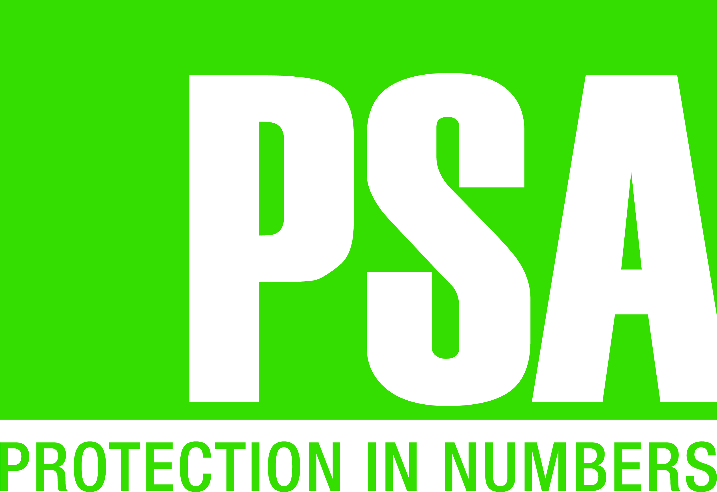
Public Service Association of South Australia Inc.
HOLIDAY HOME BOOKING REQUEST
FOR NEW ZEALAND PSA MEMBERS
Thank you for your interest in staying at a PSA Holiday Home in South Australia.
Please complete this form nominating which location you are interested in staying at and what linen you require, if any. Cost of linen is AUD $10.00 per bed.
Email your completed request form to: holidayhomes@psaofsa.asn.au

NEW ZEALAND PSA MEMBER NUMBER:
NAME:
ADDRESS:
TELEPHONE WORK: MOBILE:
EMAIL:

DATE REQUIRED: | From: _____ / _____/ _____ | To: _____ / _____/ _____

LOCATION  [Please select] | LINEN REQUIREMENTS  [Cost: AUD $10.00 per bed]

LOCATION OF HOME | NUMBER OF OCCUPANTS | SELECT | BEDDING AVAILABLE | SELECT OPTION | NUMBER OF BEDS REQUIRED
GLENELG [Unit 16] | 6 per unit | ☐ | 1 x Queen | ☐
 |  |  | 2 x Single Bunks (4 Beds) | ☐
GLENELG [Unit 20] | 6 per unit | ☐ | 1 x Queen | ☐
 |  |  | 1 x Bunk  - Single Bed (Top)  - Double Bed (Bottom) | ☐  ☐
 |  |  | 1 x Single Bed | ☐
GOOLWA [2 Units] | Up to 7  per unit | ☐ | 1 x Queen | ☐
 |  |  | 1 x Single Bunk(2 singles)  1 x Double Bed (bottom) with 1 x Single bunk bed above | ☐  ☐  ☐
KANGAROO ISLAND [1 House] | 6 per house | ☐ | 1 x Queen | ☐
 |  |  | 1 x Single Bunk (2 Singles) | ☐
 |  |  | 2 x Single Beds | ☐
PORT LINCOLN [1 Unit] | 6 per home | ☐ | 1 x Queen | ☐
 |  |  | 2 x Single Bunks (4 Beds) | ☐
PORT VINCENT [2 Units] | 6 per unit | ☐ | 1 x Queen | ☐
 |  |  | 2 x Single Bunks (4 Beds) | ☐
ROBE [3 Units] | 5 per unit | ☐ | 1 x Double | ☐
 |  |  | 1 x Bunk  - Single Bed (Top)  - Double Bed (Bottom) | ☐  ☐
WIRRINA [1 Unit] | 5 per unit | ☐ | 1 x Queen | ☐
 |  |  | 1 x Bunk  - Single Bed (Top)  - Double Bed (Bottom) | ☐  ☐

RATES [Prices subject to change] | ON SEASON  1 October -  31 May | OFF SEASON  1 June -  30 September | NIGHTLY
KANGAROO ISLAND HOME | $600.00 | $455.00 | $90.00
ALL OTHER UNITS | $495.00 | $355.00 | $90.00

IMPORTANT NOTE
This is not a guarantee of availability. You will be contacted via email to confirm your booking.
Payment will not be processed until confirmation has been received.

TERMS AND CONDITIONS

Terms and conditions are available to review on the PSA website: www.psaofsa.asn.au/holiday-homes
By signing this form you are agreeing to abide by our terms and conditions.

I agree to the terms and conditions:

Signature:_________________________________________________ Date: _______________________

PAYMENT DETAILS
Accommodation Amount AUD: | $
Linen Requirement - Number of beds ________ at AUD $10.00 per bed: | $
TOTAL AUD: | $

Card Holder's Name:

Credit Card Number:

Expiry Date: / VISA Mastercard

TOTAL AMOUNT TO BE DEDUCTED: | $

OFFICE USE ONLY

BOOKING CONFIRMED: Yes ☐ No ☐
DATE PAYMENT PROCESSED:
CARETAKER NOTIFIED: Yes ☐ No ☐

CONFIRMED BY: | DATE:

/home2/PSA/administration/Member Benefits/Holiday Homes/Photos for Website/Booking request new zealand psa members UPDATED.odt

