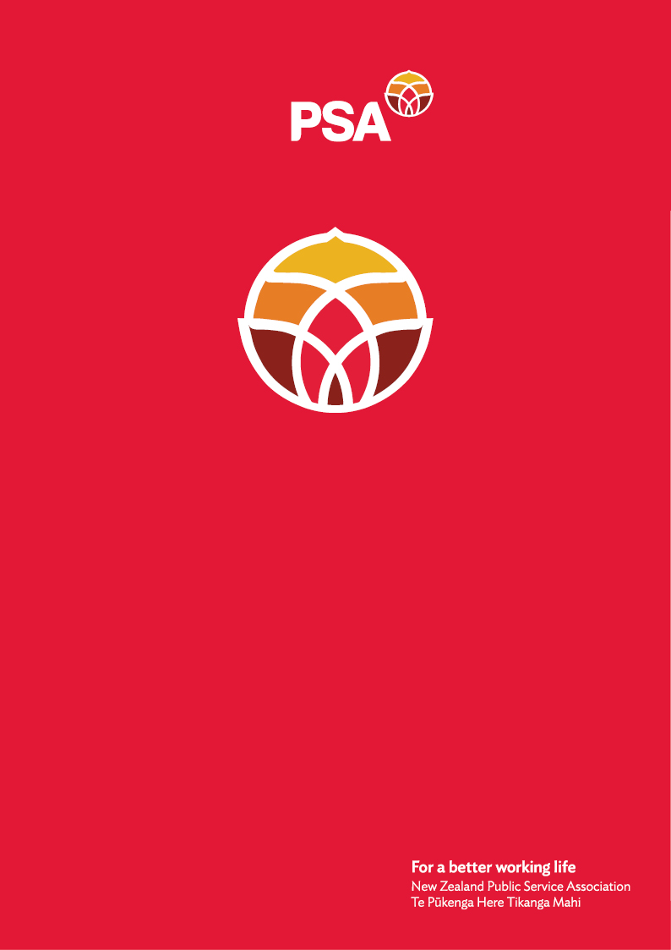

**PSA Submission**

**on the**

**Employment Relations**

**(Pay Deductions for Partial Strikes)**

**Amendment Bill**

January 2025

## Introduction

The New Zealand Public Service Association Te Pūkenga Here Tikanga Mahi (the PSA) is the largest trade union in New Zealand with over 96,000 members. We are a democratic organisation representing members in the public service, the wider state sector (Te Whatu Ora, crown research institutes and other crown entities), state owned enterprises, local government, tertiary education institutions and non-governmental organisations working in the health, social services and community sectors.

The PSA has been advocating for strong, innovative and effective public and community services since our establishment in 1913. People join the PSA to negotiate their terms of employment collectively, to have a voice within their workplace and to have an independent public voice on the quality of public and community services and how they are delivered.

The PSA is affiliated to Te Kauae Kaimahi the New Zealand Council of Trade Unions, Public Services International (PSI) and UniGlobal. We support the CTU’s submission on this Bill.

### **Our values**

Solidarity - Kotahitanga

We champion members’ interests with a strong effective voice. We stand together, supporting and empowering members, individually and collectively.

Social justice - Pāpori Ture Tika

We take a stand for decent treatment and justice. We embrace diversity and challenge inequality.

Integrity and respect - Te Pono me te Whakaute

Our actions are characterised by professionalism, integrity and respect.

Solution focused - Otinga Arotahi

We are a progressive and constructive union, constantly seeking solutions that improve members’ working lives.

Democratic - Tā te Nuinga e Whakatau ai

We encourage participation from members. We aim to be transparent, accessible and inclusive in the way we work.

## Why we oppose the Employment Relations (Pay Deductions for Partial Strikes) Amendment Bill

We oppose this Bill because it is not in line with the objects of the Employment Relations Act 2000, in particular, the legislative requirement for good faith behaviour, acknowledging and addressing the inherent inequality of power in employment relationships, and reducing the need for judicial intervention, and the **right to be paid no less than the minimum wage under the Minimum Wage Act** 1983. We champion members’ interests with a strong effective voice. Taking industrial action is about standing together, supporting and empowering each other. Industrial action is a powerful mechanism to challenge inequality and exclusion. The ability of workers to take industrial action is recognised as a crucial lever to assist in balancing power in the workplace.

**Purpose of the Bill**

The Bill’s explanatory note states that the Bill is aimed at incentivising parties engaged in industrial action to reach agreement sooner. There is no evidence to support this contention. In fact, the Bill is likely to further exacerbate conflict. The Bill essentially discourages employers from engaging with unions in a constructive and respectful way.

Under the provisions of the Bill:

* An employer can deduct pay when an employee is working at full capacity and workload has not reduced;
* A 10% pay reduction can be effected in such situations and without justification.
* A worker can be paid less than the minimum wage, while undertaking a full output of work.
* The employer does not have to inform the employee of the amount that will be deducted until the deduction takes place.

These provisions are contrary to the basic principles of ‘wages for labour’ as it allows less wages to be paid where the same output of work is occurring.

**The Bill provides for punitive measures without justification**

No worker takes industrial action in form of partial strikes lightly. Industrial action is adopted when all other means have been assessed in good faith and exhausted with out successful resolution of the issues. Enabling an employer to make pay deductions while workers are on strike is not a constructive way to find a solution to the conflict. If anything, it will exacerbate the conflict. Our members want to be respected and valued for their contribution and demand workplace participation to find the best possible solutions through negotiations.

PSA members sometimes utilise partial strike action. This commonly occurs where bargaining is occurring for provisions relating to issues such as understaffing. For example, where workers are not receiving their contractual break entitlements, due to understaffing, workers may choose to collectively enforce their break entitlements. In such a situation, an employer would be entitled to reduce the workers’ salary by 10%.

The ‘inherent inequality of power’ that the Employment Relations Act 2000 seeks to address relates to the inherently stronger power of the employer to essentially make decisions in the workplace that impact on workers. The right to freedom of association, to collective bargaining and to strike are mechanisms to redress the imbalance of power as recognised by the International Labour Organisation (ILO). This further enhances the power imbalance towards employers and **increases the inequality of power.**

The Bill grants power to an employer to withhold from the worker resources they need to meet their basic living costs. An employer does also not have to inform workers as to the amount it intends to deduct, which leaves workers in a position of uncertainty. The purpose of the Bill is to try and prevent workers from utilising partial strike action, rather than achieving balance of power. If bargaining has reached a deadlock (the point at which industrial action usually occurs) then disincentivising partial strike action is only likely to push the parties towards full withdrawal of labour or lockout. It is also important to mention that the deduction of pay is a direct benefit to the employer.

The regulatory impact statement (RIS) shows no robust evidence on the effectiveness of the Bill. Clear evidence of the impacts of these measures should be available as these amendments have been previously enacted and repealed.

The Bill undermines Aotearoa New Zealand’s obligations for **international labour standards**. Interestingly, in the regulatory impact statement (RIS) relevant statements in relation to consistency with international obligations including labour standards are redacted. As highlighted in the CTU submission, the Bill misaligns with *ILO Convention 98 (Right to Organise and Collective Bargaining Convention, 1949* in that it enables discriminatory treatment of workers engaging in lawful union activity. This breach is particularly concerning when it undermines the pay rates of union members or where union members engaging in lawful activities will no longer be protected by Minimum Wage legislation.

The Bill **will draw out collective bargaining and increase costs** for all parties. Allowing employers to make deductions from the pay of those who take partial strike action will potentially lead to time and money being spent on administrating and litigating the amount to be deducted. A likely result of this Bill, as alluded to above, will be to push workers to fully withdraw their labour earlier, which will rapidly escalate and entrench bargaining disputes.

In addition, it is anomalous that while a union may challenge the calculation of a specified deduction, there is no ability to challenge an employer’s decision to make the 10% deduction.

**In summary**, the PSA’s position is that this Bill is an attack on the rights of working people and their ability to negotiate for fair and just terms and conditions by increasing the inequality of power between the employer and the worker even further. As highlighted by the CTU in its submission, the PSA is also concerned that this Bill adds to the growing number of breaches of international labour law and thereby adding uncertainty for New Zealand industrial relations, the economy and the wellbeing of people.

For further information, please contact:

Andrea Fromm

Senior Advisor, Policy and Strategy

New Zealand Public Service Association (PSA) Tē Pūkenga Here Tikanga Mahi

PO Box 3817, Wellington 6140

Mobile: 027 5816170 | Email: [andrea.fromm@psa.org.nz](mailto:andrea.fromm@psa.org.nz)