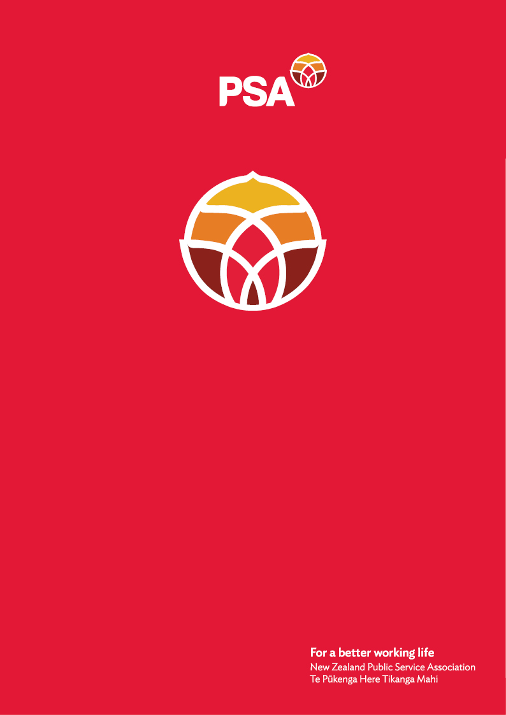

**PSA Submission of the**

**ALMA Network**

**On the**

**Treaty Principles Bill**

December 2024

## Introduction

The New Zealand Public Service Association Te Pūkenga Here Tikanga Mahi (the PSA) is the largest trade union in Aotearoa New Zealand with over 96,000 members. We are a democratic organisation representing members in the public service, the wider state sector, local government and non-governmental organisations working in the health, social services and community sectors.

## Who is the ALMA network?

We are PSA members from Asian, African, Latin American, and Middle Eastern communities. We are the youngest PSA network found in 2023 with currently 1,228 members. The PSA’s ALMA Network provides an opportunity for members to come together and form a collective voice for workers from these communities regarding work issues, share advice and provide support. We see the network’s activities as an opportunity to contribute to shaping the Aotearoa New Zealand we wish to see. Te Tiriti as the founding document provides guidance to us on how we live and work together in Aotearoa.

Our members are underrepresented in the public service, local government and community sector, especially in leadership roles. Many of us come from countries with a colonial past and we recognize the historical and ongoing disparities faced by Māori as our own experiences of marginalization resonate which deeply with theirs. Together, we share common challenges, including persistent pay gaps, limited representation in leadership roles, and everyday barriers to equality.

In 2024, the gender pay gap in the Public Service was 6.1%. When looking at the ethnic pay gap, in 2024, the Māori pay gap was 4,8%, the Pacific pay gap was 17.2%, and the Asian pay gap, 13.8%.

When looking at gender and ethnicity together, Public Service men are paid more on average than women in each ethnic group, and Europeans are paid more on average than other ethnicities. This reflects the way that gender and ethnic bias compounds for Māori, Pacific and ethnic women.

Alongside the impact of bias and discrimination has on pay gaps, both gender and, ethnic pay gaps can reflect occupational segregation or the occupation profile of a particular ethnic group. Māori, Pacific and Asian public servants are over-represented, to varying degrees, in lower-paid occupation groups.

Although we don’t often get granular statistics on the ethnic communities we represent, we know they face similar barriers and have similar pay gaps, based on their anecdotal experiences and the statistical trends of other ethnic groups.

The ALMA network stands in solidarity with Māori. We recognise Māori as tangata whenua and stand strong in support for and defence of te Tiriti o Waitangi. Our shared experiences of marginalisation and exclusion unite us in our pursuit of equity and representation. We recognize the value of collective action, solidarity, and shared advocacy to address these injustices. By working together, we can amplify our voices, challenge dominant narratives, and create a more equitable future for all.

## Why we reject the Treaty Principles Bill

* The Bill has nothing to do with equity, instead, it aims to erase Māori rights and uses colour-blinded narratives that foster further discrimination to ethnic minorities.
* Te Tiriti is the constitutional foundation of our country, it enables Kotahitanga and for all to come together under one umbrella, including migrants as Te Tiriti is not just about Māori it’s also about non-Māori. Te Tiriti allows people of all cultures the right to make this country home. This attempt to redefine Te Tiriti is an act of cultural assimilation. We want the next generation of mokopuna and growing ethnic communities including migrants from Asia, Middle East, Africa and Latin America to live in a country that celebrates the richness of diverse cultures.
* Colonialism has produced a system of white supremacy that has undermined and persecuted Māori over the years. This has created intergenerational trauma and systemic inequalities that can be seen by the overrepresentation of Māori in negative statistics such as life expectancy, maternal mortality rates, health issues, prison population, criminal justice system, children under state care, etc. Te Tiriti holds the Crown to its obligation to guarantee tino rangatiratanga to Māori and therefore make explicit efforts to compensate Māori for the effect of the theft of land and the ongoing racial discrimination and bias, that translate into barriers and marginalisation of Māori. Māori do not always have a level playing field with other New Zealanders, and equitable treatment is required to ensure outcomes that are more equal. Equality without equitable treatment does not capture the promises made in article 3 or the meaning of the te Tiriti as a whole.
* If the Treaty Principles Bill passes, the efforts the past government made to build te reo Māori competency within the public services will be undermined, as it won’t be seen as a priority anymore, which would set a bad precedent for other ethnic communities. We have already seen attempts to forbid the use of languages different to English, in some health care centres, and this would only exacerbate and endorse this type of discrimination, which will create an unsafe space for ethnic communities to use their language, customs and cultural practices.
* Te Tiriti of Waitangi was signed between two parties. The Treaty Principles Bill makes a unilateral interpretation of Te Tiriti that does not acknowledge Māori, thereby diminishing the mana of Māori and the core principle of the agreement between Māori and the Crown.
* If this Bill passes, it will have a detrimental impact on Aotearoa NZ’ international human rights status. In 2010, Aotearoa NZ the Government indicated its support for the UN Declaration on the Rights of Indigenous Peoples as “both an affirmation of existing rights and [an] expression of new and widely supported aspirations”. This declaration forms part of the international human rights framework and reinforces te Tiriti and its reciprocal relationships between indigenous people and the state.
* Te Tiriti is the basis for upholding the rights of Māori people, its language, customs and values. The Treaty Principles Bill doesn’t have any connection with the original treaty that was signed. Instead of honouring this commitment, it challenges Māori tino rangatiratanga and jeopardise the relationship between Māori and the Crown.
* Te Tiriti is embedded within government. Many pieces of legislation have incorporated the principles of the Treaty. Te Tiriti informs how policies get developed and delivered, this involves engaging with Māori and making sure that all policies have positive outcomes for Māori.
* A Tiriti-led approach can promote different ways of understanding and approaching climate change, and elevate Kaitiakitanga, which is the Māori concept of guardianship and protection, which refers to the responsibility to care for the land, water, and other natural resources for future generations. Te Tiriti protects Māori sovereignty over their lands, resources, and the natural environment, which is culturally, spiritually, and economically significant.
* The Bill is opposed by iwi and hapu across Aotearoa, as well as by Pakeha and ethnic minority groups. 50,000 people took part in the hikoi in Wellington alone to show their disagreement and 291,598 people have signed a petition against it (data up to 9 December 2024).

For further information, please contact:

Andrea Fromm

Senior Advisor, Policy and Strategy

New Zealand Public Service Association (PSA) Tē Pūkenga Here Tikanga Mahi

PO Box 3817, Wellington 6140

Mobile: 027 5816170 | Email: [andrea.fromm@psa.org.nz](mailto:andrea.fromm@psa.org.nz)