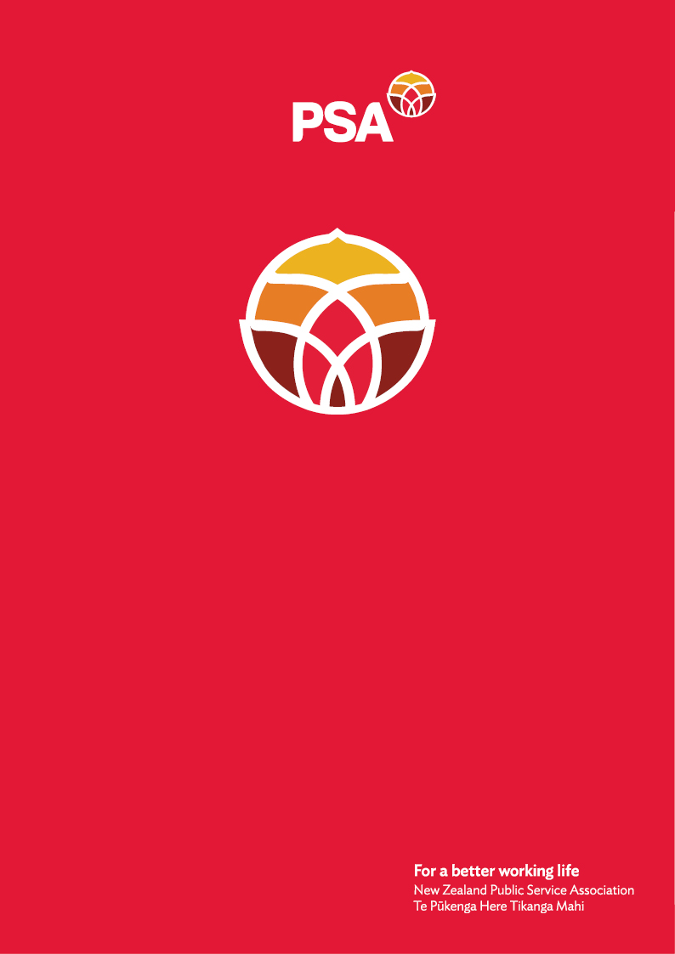

**PSA Submission of the Community Public Services Sector Committee on the**

**Treaty Principles Bill**

December 2024

## Introduction

The New Zealand Public Service Association Te Pūkenga Here Tikanga Mahi (the PSA) is the largest trade union in New Zealand with over 96,000 members. We are a democratic organisation representing members in the public service, the wider state sector, local government and non-governmental organisations working in the health, social services and community sectors.

## Who is the Community Public Services Sector Committee?

We are employees of the Community Public Services Sector. We represent around 10,000 members in over 350 not-for profit and for-profit organisations that receive public funding to deliver health services. The Community Public Services (CPS) sector covers people working in the community in the areas of disability, mental health and addictions, home support, and social services. We are community home support workers, community residential care workers, team leaders, community social workers, whānau workers, community youth workers, whānau ora navigators, activities coordinators, community mental health workers etc.

Our employers tender for government funding to provide needed services in the community. We look after the most vulnerable people in our communities, providing essential daily care to people in their own homes and supporting people to live independent lives. Our workforce is mostly made up of women, a large proportion of whom are Māori, Pasifika, and ethnic minorities. Of our members, 82% are women, who struggle with job insecurity (about 12% are casual workers) and low pay.

Although our work is acknowledged to be essential, we often still feel undervalued as there is an expectation by our employers that we will work flexibly to meet our clients' needs - even though we also have family obligations of our own. Many of us work shifts or have variable hours of work. We have had to fight for every element of reasonable pay, such as payment for sleepovers and travel time. Many support workers still do not have guaranteed regular breaks during their working day or consistent weekly hours of work.

What is good for Māori is good for everyone. We are speaking out for solidarity and unity. We are standing together.

## Why we reject the Treaty Principles Bill

* The CPS Sector Committee believes that the Treaty Principles Bill is a divisive distraction that is taking away time and energy that should be put into addressing the most pressing issues facing Aotearoa New Zealand like the cost of living, poverty, Health and Disability funding cuts and the provision of community services.
* Money and time are being wasted by this government by progressing this Bill which would be better invested into for instance pay equity for care and support workers, back paid holiday pay and increasing cultural knowledge and safety for everyone in the sector.
* The attacks on workers’ rights, the disestablishment of Te Aka Whaiora, fast tracking Bills and changes without allowing full democratic participation by the public are all making it harder for young CPS workers to justify staying in Aotearoa to work for their community and holding their whānau together.
* The way this Bill has been created is appalling. No Māori leader, iwi or community representatives have participated in this draft Bill. An agreement between two parties cannot be changed unilaterally.
* This Bill undermines the Crown's relationship with Tangata Whenua. It also undermines the good faith relationship between the Crown, the Public Service and publicly funded services as an extension.
* MPs may receive letters, they may see hikoi, but it is we, the front-line delivering community services, who receive face-to-face, one-on-one, personal reactions to the choices of this government. We provide the front-line services which are required for the continuation of our society on behalf of the government. When the government undermines te Tiriti, we have to manage the negative feedback.
* Te Tiriti is the foundation for policies and practices aimed at enabling equitable treatment and reconciliation. Te Tiriti guides tangible actions in areas such as healthcare and community services to address disparities faced by Māori communities. Modifying or reinterpreting these principles perpetuates systemic inequalities and deepens mistrust between Māori and the Crown.
* There is no denying there is strain on community public service workers as a direct result of the structural disadvantages whānau Māori face due to the mountain of Te Tiriti breaches:
  + honouring Te Tiriti, especially the commitments to Tino Rangatiratanga and Ōritetanga, is key to addressing the structural disadvantages and resulting strain on community public service workers
  + The proposed changes erode and confuse the authority of Māori to define and act on our aspirations.
  + The proposed changes also appear to undermine government acting in an equitable way for Māori impacted by breaches.
* The Bill doesn’t demonstrate any respect for te ao Māori and tikanga. We are concerned that this will be reflected in community providers’ service provision and lead to entrenched inequitable outcomes for Māori.
* We worry that the Bill will substantially limit enabling choice on who provides services. Iwi and whanau ora providers will bear the detrimental consequences of the Bill.

For further information, please contact:

Andrea Fromm

Senior Advisor, Policy and Strategy

New Zealand Public Service Association (PSA) Tē Pūkenga Here Tikanga Mahi

PO Box 3817, Wellington 6140

Mobile: 027 5816170 | Email: [andrea.fromm@psa.org.nz](mailto:andrea.fromm@psa.org.nz)