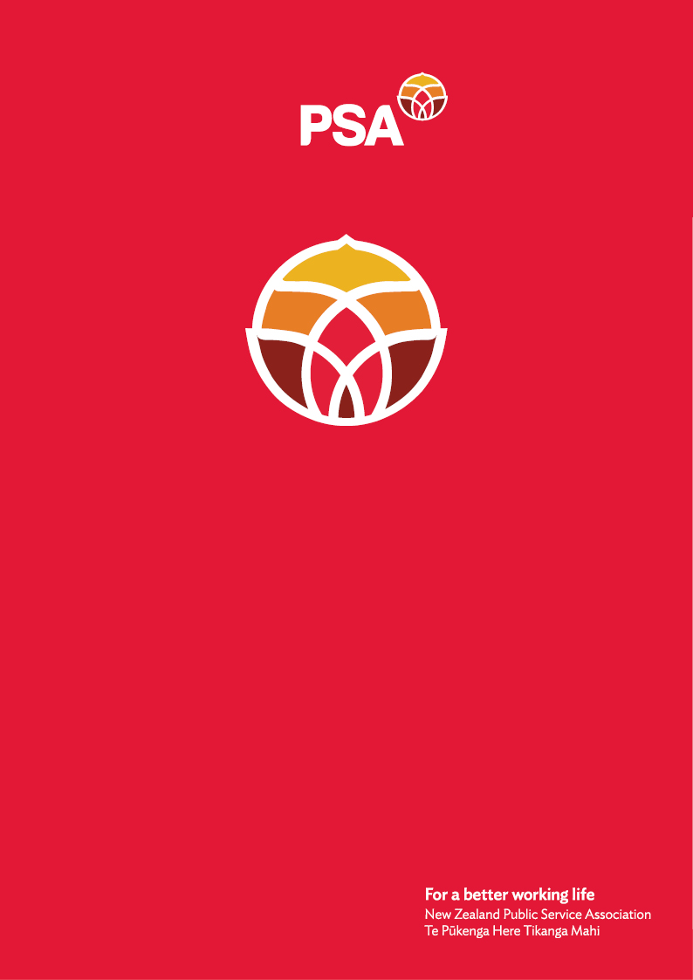

**PSA Submission of the**

**MHAC Committee**

**On the**

**Treaty Principles Bill**

December 2024

## Introduction

The New Zealand Public Service Association Te Pūkenga Here Tikanga Mahi (the PSA) is the largest trade union in New Zealand with over 96,000 members. We are a democratic organisation representing members in the public service, the wider state sector, local government and non-governmental organisations working in the health, social services and community sectors.

## Who is the MHA Committee?

We are the PSA Mental Health and Addictions Committee (MHAC). We are members working in mental health services in Health, in the community, and in core public service agencies.

The PSA and the MHAC have a historic connection to mental health services. Our membership in the sector goes back to the days when mental health services were delivered directly by the Department of Health and the range of our membership has expanded since those days. We have been actively involved in advocating for better mental health and addiction services for many years, and in the 1990s were part of a movement that led to the Mason Report and the publication of the original Blueprint for Mental Health Services in New Zealand. More recently we have made a submission on He Ara Oranga: Report of the Government Inquiry into Mental Health and Addiction. We have also submitted on subsequent pieces of legislation and strategic policy documents related to implementing the recommendations of He Ara Oranga.

We know that achieving (mental) health equity and cultural safety will be severely challenged by the Bill. We speak out against a Bill that harms people’s wellbeing.

## Why we reject the Treaty Principles Bill

The MHAC recognises Māori as tangata whenua and stands strong in support for and defence of te Tiriti o Waitangi.

* We reject the Bill because it continues to foster intergenerational trauma rather than trying everything to stop it and reconcile past injustices.
* Especially the Treaty Principles Bill’s rewrite of article 2 subjugates Tino Rangatiratanga o Tangata Whenua to the general good of all New Zealanders. In this sense it thwarts Māori ability to feel confident with Tangata Tiriti to achieve the same outcomes together when equity is ill-defined.
* Māori are already overrepresented in negative health statistics including mental health. This will likely get worse, and health inequities become more pronounced.
* The Treaty Principles Bill will further erode the specific resourcing required to support Māori who access mental health services. This is likely to mean less health providers run by Māori; less commitment to recognising and acknowledging Te Tiriti o Waitangi by organisations such as Te Whatu Ora.
* There will be less focus and expectation on the workforce to be culturally responsive; less expectation for workers to understand the purpose of Te Tiriti; less understanding of the effects of colonisation on Māori.
* It will also impact on the ability of the workforce and community to fulfil the expectation of the new Mental Health Act when finally passed.

The MHAC stands together with our Tangata Whenua colleagues to rebuke ACT’s Treaty Principles Bill.

For further information, please contact:

Andrea Fromm

Senior Advisor, Policy and Strategy

New Zealand Public Service Association (PSA) Tē Pūkenga Here Tikanga Mahi

PO Box 3817, Wellington 6140

Mobile: 027 5816170 | Email: [andrea.fromm@psa.org.nz](mailto:andrea.fromm@psa.org.nz)