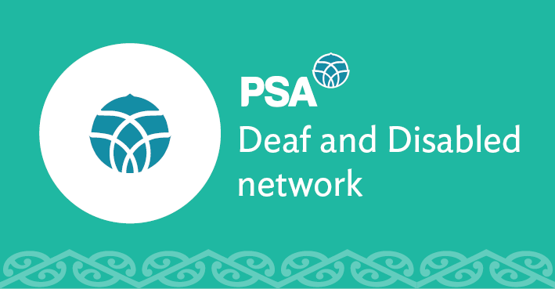

PSA Deaf and Disabled Network Submission

on the

Treaty Principles Bill

December 2024

About PSA Deaf and Disabled Network
The PSA Deaf and Disabled Network represents 1,500 Deaf and Disabled workers in the PSA. The Deaf and Disabled members’ network is a space within the PSA for members who identify as living with a disability to network, organise, share ideas and influence the direction and focus of the PSA.
The PSA is the largest trade union in New Zealand with over 96,000 members. We are a democratic and bicultural organisation representing people working across the country in public and community services. We are committed to advancing the Tiriti o Waitangi principles of partnership, protection and participation through our work. Te Rūnanga o Ngā Toa Āwhina is the Māori arm of the PSA membership.

PSA Deaf and Disabled Network response to the Bill
This submission sets out PSA Deaf and Disabled Network’s response to the Treaty of Waitangi Principles Bill. We strongly oppose this bill and our recommendation is that it is not progressed. We also oppose the plans announced by the Government to remove reference from other legislation to Te Tiriti o Waitangi. The select committee should report back to Parliament with a recommendation that this bill should not proceed.

Reasons why we oppose this bill
As Deaf and Disabled, we opposed this bill because Te Tiriti is not currently honoured, and this bill would make it worse:
- Removing Māori self-determination removes and discriminates against the right of Tangata Whaikaha to determine their own identity and care.
- There is over representation of Tangata Whaikaha Māori in disability support services and in the disabled population overall. There are not enough hauora Māori service providers of disability supports. The disability system, including needs assessments, eligibility, the definition of disability and processes and engagement is not culturally inclusive or responsive to iwi, hapu or whanau.
- For Turi Māori (Māori Deaf people) the inequity is extreme, and the ability to connect with tikanga and mātauranga is limited.
- The government is obligated to be a good treaty partner by providing Tangata Whaikaha Māori options that enable tino rangatiratanga over their supports, equity of outcomes alongside non-disabled people, redress of wrongs through things like affirmative action, and to work in partnership with iwi, hapu and Māori.

Te Tiriti and He Whakaputanga are the founding documents of Aotearoa New Zealand. We oppose the bill as Māori and Tangata Tiriti because:

- The government is obliged under te Tiriti o Waitangi to enable tino rangatiratanga under article 2 of te Tiriti. The government is obliged to provide good kaawanatanga (governance).
- The current te Tiriti principles decided through the courts, tribunal and tikanga provide the foundation for this to be addressed.
- This is why the rhetoric of “equal opportunity” and “equality for all New Zealanders” in the bill is flawed. We don’t and can’t all start from the same place. There is historic, colonial abuse and trauma that has shaped an inequitable society causing significant generational damage to Māori. This means New Zealanders are not equal.

Honouring te Tiriti is the solution - not the problem. Recognising mātauranga iwi, hapu and whanau is the solution. Accepting tino rangatiratanga is the solution.

For further information, please contact:
Grace Millar
Advisor, Policy and Strategy
New Zealand Public Service Association (PSA) Tē Pūkenga Here Tikanga Mahi
PO Box 3817, Wellington 6140
Mobile: 027 700 3417 | Email: grace.millar@psa.org.nz

