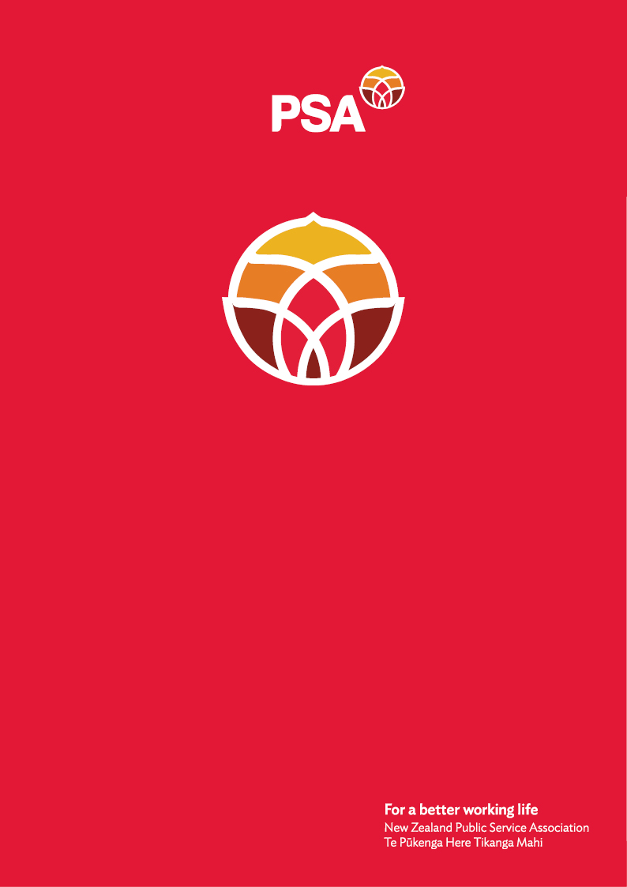

**P** **SA Te Whatu Ora:**

**Health Sector Submission**

**on the**

**Treaty Principles Bill**

December 2024

# About PSA Te Whatu Ora: Health Sector

The Te Whatu Ora: Health Sector represents over 25,000 members in Te Whatu Ora. Just under 10% of our members are Māori. Our members work as mental health nurses and assistants; public health nurses; allied health, scientific and technical professionals and assistants; administrative and clerical staff; policy and other knowledge workers and managers.

The PSA is the largest trade union in New Zealand with over 96,000 members. We are a democratic and bicultural organisation representing people working across the country in public and community services. We are committed to advancing the Tiriti o Waitangi principles of partnership, protection and participation through our work. Te Rūnanga o Ngā Toa Āwhina is the Māori arm of the PSA membership.

# PSA Te Whatu Ora: Health Sector response to the Bill

This submission sets out PSA Te Whatu Ora: Health Sector’s response to the Treaty of Waitangi Principles Bill. We oppose this bill and strongly commend that it not progressed. We also oppose the plans announced by the Government to remove reference from other legislation to Te Tiriti o Waitangi. The select committee should report back to parliament that this bill should not be progressed.

# Reasons why we oppose this bill

As health workers we oppose this bill, because we believe that honouring Te Tiriti will strengthen the health system:

* Māori face inequities within the health system and this will not be solved without honouring Te Tiriti and addressing inequity for Māori workers.
* Our goal is to enable our Māori staff practice and embrace Manaakitanga as we see fit in accordance with tikanga Māori.
* Our members are treated in a tokenistic way as health workers and their knowledge is not valued. During Covid, we were allowed to become nonclinical vaccinators, which increased Māori vaccination rates. Once that was over, we were surplus to requirements.
* We’re concerned that Te Tiriti is currently not being honoured. The removal of equity-based roles would further widen health inequalities, already faced by Māori within our service.
* Te Tiriti helps align our common goals with other stakeholders, government/regional/or local agencies. For instance, in the recreational water space – we work closely with regional councils monitoring beaches/rivers and kaimoana sites in order to protect recreational users from getting sick. If there is an exceedance (e.coli, algae bloom, etc) Public Health release a media statement joint with our local Government. However, due to a long working relationship with local Rūnanga (nurtured by Te Tiriti), they too get a notification of the local risk and pass on the information to their people.

We also oppose the bill as Māori and Tangata Tiriti, because we believe it is a founding document of New Zealand.

* Te Tiriti o Waitangi is the written word of tipuna and the Crown, it is tipuna ensuring Māori remain Rangatira. However, the Crown has yet to honour it.
* Te Tiriti ensures that Māori are granted the same rights as other people within this country.
* Tino rangatiratanga is recognised under te Tiriti as Māori sovereignty. There is already sovereignty from the non-Māori perspective which is the Crown. This bill removes the sovereignty status of Māori.

This referendum is outrageous, stripping away Māori rights. Once again Māori are being undermined as tangata whenua of Aotearoa. We can and do whakapapa to Io Matua Kore, we are te whenua, te moana, te aoturoa there is no separation between us te tangata and us te whenua, te taiao.

For further information, please contact:

Grace Millar

Advisor, Policy and Strategy

New Zealand Public Service Association (PSA) Tē Pūkenga Here Tikanga Mahi

PO Box 3817, Wellington 6140

Mobile: 027 700 3417 | Email: [grace.millar@psa.org.nz](mailto:grace.millar@psa.org.nz)