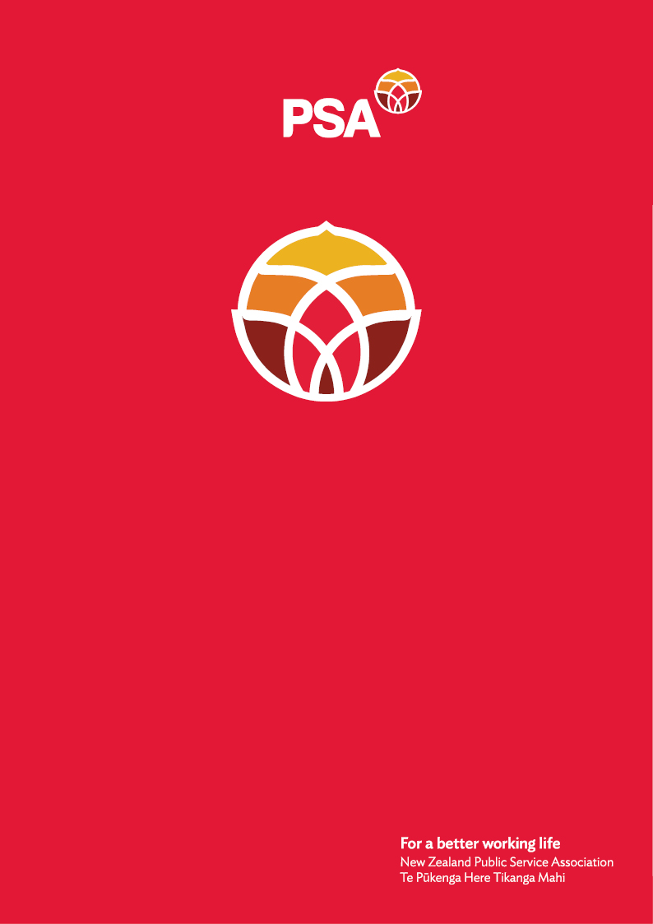

**PSA Submission of the**

**PSAY Network**

**on the**

**Treaty Principles Bill**

December 2024

## Introduction

The New Zealand Public Service Association Te Pūkenga Here Tikanga Mahi (the PSA) is the largest trade union in New Zealand with over 96,000 members. We are a democratic organisation representing members in the public service, the wider state sector, local government and non-governmental organisations working in the health, social services and community sectors.

## Who is the PSAY?

PSA Youth (PSAY) is a vibrant and active branch of the Public Service Association (PSA). We work across all sectors, from public service to health, education, to state and community services. We are 27,000 young workers aged under 35 and together we are the largest youth union network in the country and are passionate about creating a better Aotearoa for all - one that honours our history while building a future grounded in equity and inclusivity.

As the future of the union, we understand the importance of Te Tiriti o Waitangi in shaping our workplaces, our communities, and our shared vision for Aotearoa.

PSA Youth advocates for the rights, interests, and welfare of young workers, ensuring that their voices are heard in the workplace and in wider societal issues. Our commitment to social justice and equity informs our position on matters affecting our communities, including the representation of tangata whenua in Aotearoa.

PSAY is dedicated to:

* Promoting the interest of young people within the PSA.
* Facilitate the sharing of information and experiences.
* Encourage and support young people’s participation in the representative structure at all levels of PSA.
* Advocating for policies that support the professional development and well-being of our members.
* Ensuring that young people are actively engaged in shaping the future of the public service.
* Upholding the principles of the Treaty of Waitangi in all our activities and advocacy efforts.

## Why we reject the Treaty Principles Bill

The suggestion of a referendum on Māori rights and Te Tiriti principles is harmful and divisive. It simplifies complex issues into binary choices, undermines the partnership Te Tiriti represents, whilst doing so is amplifying misinformation. As young New Zealanders, we reject this step backward.

We know that Te Tiriti o Waitangi drives positive change in our workplaces and the services they deliver. It challenges outdated systems, promotes equity, and ensures Māori voices are heard at decision-making tables. These principles make workplaces more inclusive for kaimahi Māori, who bring invaluable insights and cultural wisdom to their roles and to the teams we both belong together in.

When services are co-designed with Māori and informed by their mātauranga, everyone benefits. The public service becomes more whānau-focused, relevant, and effective. This is especially important for young workers, who are navigating work opportunities with creating and building their families, in a dynamic and harsh economic environment. Policies created by Māori, for Māori, don’t just address the intergenerational trauma caused by colonialism—they lead to real-world solutions that uplift entire communities.

By embedding the current principles of Te Tiriti in decisions that shape Aotearoa New Zealand, we’re shaping a future where equity isn’t just a buzzword but a standard practice.

**From the National Co-Convenor of PSAY**

"As a young tangata Tiriti, my connection to Te Tiriti is both historical and deeply personal. My ancestors came to Aotearoa under varied circumstances—kauri felling, military service (Fencibles), and ceded governance in the Pacific to the British Crown. They thrived here because of the opportunities Te Tiriti provided, but I often wonder if they truly understood the cost to tangata whenua—the loss of land, language, and culture.

Supporting Te Tiriti isn’t about guilt; it’s about gratitude and respect. Māori welcomed my whānau to this whenua with manaakitanga, and their resilience and generosity inspire me every day.

Having Niuean heritage, I can’t ignore the contrast: New Zealand respects my homeland’s self-determination while denying tangata whenua the same. We should embrace Te Tiriti to ensure Māori have tino rangatiratanga and mana motuhake. It’s not just about their rights; it’s about building a stronger, fairer Aotearoa for everyone."

**Why a Referendum Is the Wrong Move**

**Equality ≠ Equity**

Let’s be clear: equality and equity are not the same. A referendum risks reducing complex issues to a yes-or-no vote, leaving space for misinformation and prejudice to thrive. This isn’t how you address systemic inequities - it’s how you perpetuate them.

## A Better Way Forward

Instead of dividing the country, we need to:

1. **Strengthen Te Tiriti Partnerships**: Give māngai Māori real influence over policy and governance decisions.
2. **Embed Equity in Systems**: Design policies that dismantle systemic racism and build fairness into every layer of decision-making.
3. **Reject Populist Measures**: Stop using Māori issues as political footballs. Instead, invest in education and advocacy that builds understanding and solidarity with tangata whenua.

Te Tiriti is more than a historical document; it’s a living framework for an equitable and inclusive society that works for everyone.

## Conclusion

The Treaty Principles Bill and its proposed referendum are an attack on Te Tiriti, against Māori, and the progress we’ve made as a nation. PSAY urges Parliament to reject this Bill and instead invest in building a future rooted in genuine partnership with tangata whenua.

As young New Zealanders, we know the power of unity. By standing with Māori, we’re building a better Aotearoa—one where everyone has the opportunity to truly thrive and enjoy the rights and fruits of the country we live in.

For further information, please contact:

Andrea Fromm

Senior Advisor, Policy and Strategy

New Zealand Public Service Association (PSA) Tē Pūkenga Here Tikanga Mahi

PO Box 3817, Wellington 6140

Mobile: 027 5816170 | Email: [andrea.fromm@psa.org.nz](mailto:andrea.fromm@psa.org.nz)