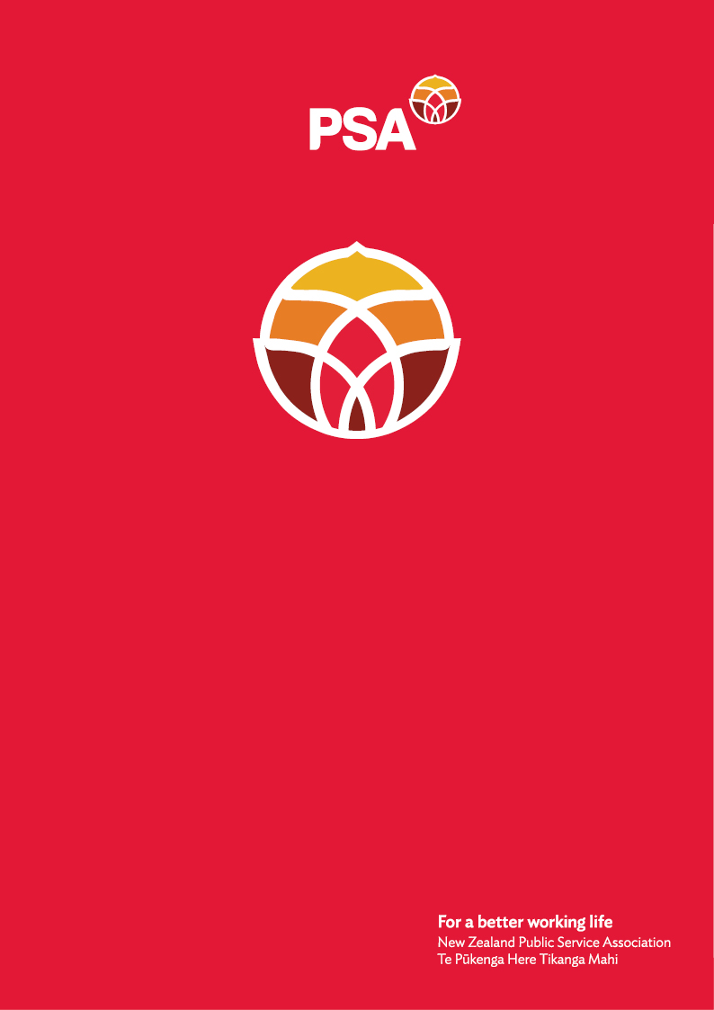

**PSA Submission of the**

**SWAN Network**

**On the**

**Treaty Principles Bill**

December 2024

## Introduction

The New Zealand Public Service Association Te Pūkenga Here Tikanga Mahi (the PSA) is the largest trade union in New Zealand with over 96,000 members. We are a democratic organisation representing members in the public service, the wider state sector, local government and non-governmental organisations working in the health, social services and community sectors.

## Who is the SWAN?

We are the PSA’s Social Worker Action Network (SWAN). SWAN provides a forum for PSA members who work as social workers. We come together and organise around the issues facing our community and ensure that the unique needs of social workers are identified and responded to. SWAN seeks to advocate for the social work community and develop a sense of cohesion, unity and strength among social workers.

## Why we reject the Treaty Principles Bill

* Te Tiriti principles have evolved through over 50 years of tested legal thinking through the court system. This is in addition to the rigorous study of the intentions and context of te Tiriti, and how it continues to have relevance in today’s changing context. The Bill does not consider, and completely ignores, these factors.
* Aotearoa is a bi-cultural nation. A Bill cannot re-write our founding document which is an agreement. Any changes need to be agreed to by both parties and not unilaterally imposed.
* The Bill is an assault to Māori and creates division.
* We have a responsibility to look after our taonga to protect and create unity for all to flourish.
* The Bill also contradicts the intention and outcomes of international human rights law including indigenous people’s rights.
* Te Tiriti ensures a focus on equitable outcomes for Māori. This Bill will contribute to entrenched inequities.
* Māori face inequitable outcomes and are disadvantaged as many statistics show such as in health, education or housing. This would be perpetuated through this Bill.
* By stripping away Māori voice and rights as a society we say that we don’t care about the wellbeing of Māori and the ability to creating the life they want to live. Social workers care about people’s wellbeing, which includes respect for Māori rights, te reo, tikanga and te ao Māori.
* This Bill also seeks to remove rights from Māori to protect vital natural resources that all of New Zealand values. We are concerned that government is seeking not just to do that through this Bill, but also through removing reference to te Tiriti principles from many other pieces of legislation.
* Rather than wasting time and resource on this Bill, money and time could have gone into investing into better social services.
* The Bill challenges intergenerational wellbeing. Not only does the Bill trample on the mana of our tipuna it also challenges the future for our mokopuna.
* We need to learn from the past. This Bill repeats past injustices and wrongdoings by unilaterally deciding and not working in partnership.
* This Bill fosters intergenerational trauma. We must break this cycle to create a better future for Māori and as a result for all of us.

For further information, please contact:

Andrea Fromm

Senior Advisor, Policy and Strategy

New Zealand Public Service Association (PSA) Tē Pūkenga Here Tikanga Mahi

PO Box 3817, Wellington 6140

Mobile: 027 5816170 | Email: [andrea.fromm@psa.org.nz](mailto:andrea.fromm@psa.org.nz)