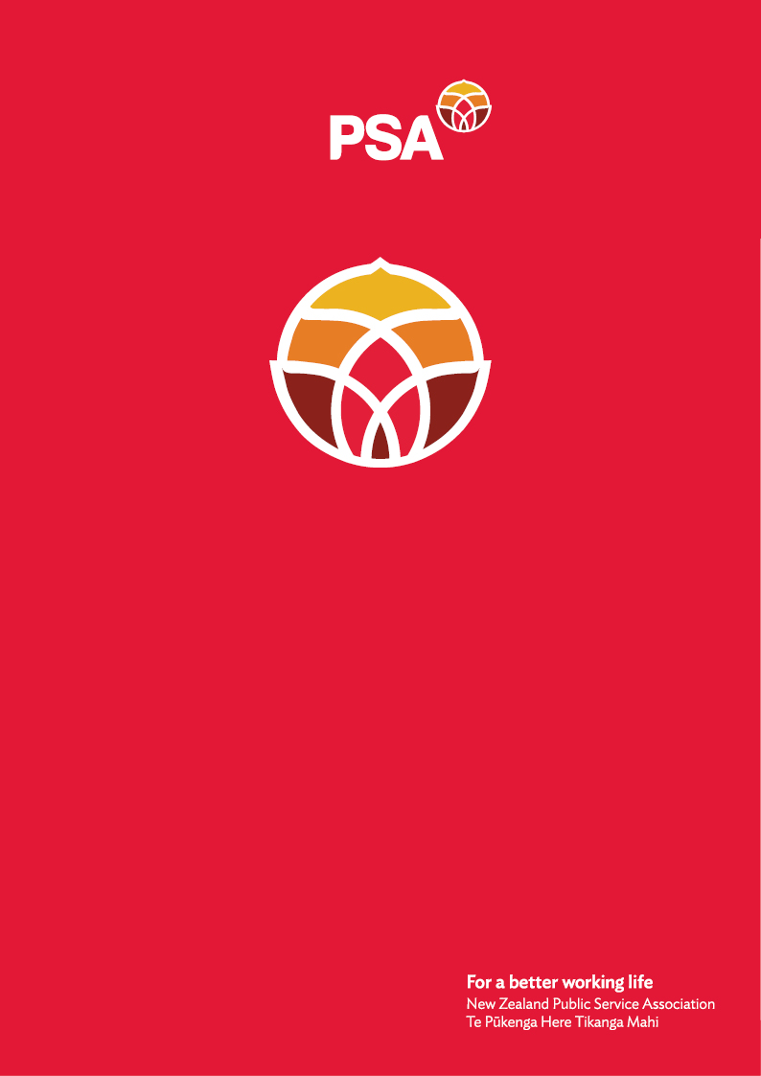  
**Survey Questions**

**Disability Support Services –**

**MSD Consultation**PSA feedback

21 November 2024

**Are you responding to this survey as a: (please select one)**

* disabled person
* family / whānau member
* carer
* service provider
* NASC
* EGL site
* community group x (Union)

We are a union.

**Which region do you live in most of the time? (please select one)**

* Northland
* Auckland
* Waikato
* Bay of Plenty
* Taranaki
* East Coast
* Central
* Wellington
* Nelson/Marlborough/West Coast
* Canterbury (including Chatham Islands)
* Southern

We represent members across the country.

**What services and supports do you receive?**

NA

**What services and supports do you provide?**

The PSA is the biggest union in Aotearoa New Zealand with over 90,000 members. The PSA represents members in the public and state sector including health, local government and publicly funded community services.

We have members who work for a variety of providers providing disability support services across the country.

We have a Deaf and Disabled Network, which has provided input into this submission.

We welcome an opportunity to continue to be involved in providing input and feedback into this very important mahi.

**Overall response to the Independent Review**

**These questions are about the future state of the Disability Support Services system.**

1. What is the role and purpose of Disability Support Services in disabled people’s and their whānau / families’, aiga and carers lives?

Disability support services (as part of a broad range of community services) add to the **public good and enhance opportunities for people to live in dignity**. Disability support services (DSS) do so by ensuring that everyone can participate in the community. Hence disability support services contribute to building strong and resilient communities.

The PSA has supported and continues to support the **enabling good lives principles** as an important way to ensure people have options to create the life they want to live. The PSA has also supported the recognition of **paid family carers** through equal pay rates comparable with care and support workers. In the words of a PSA member:

*I think these services are vital. DSS gives care and assistance to those who need it. Enabling Good Lives (EGL) provides independence and recognition of individuality and has been innovative in the support available to carers & family. It works.*

The PSA believes that maintaining **decent work in community and disability support services** will contribute to a better functioning and accessible disability support services system. Providers of disability support services should be at the forefront of **employing disabled people** who enjoy decent work including having the ability to participate in designing high-quality and relevant services. It also includes people are able to fully participate in their workplace which includes union work. A member told us that

*I feel that the Disability Support scheme is not relevant for me in the workplace and personally as we deal with different government departments and they fight over who is responsible for interpreter costs.  Eg if its EAP counselling – work pays, if its other EAP services, Health pays.  There is no one pool of funding for interpreters and it gets drawn from different government departments depending on the area.*

1. Is the role of government agencies in supporting disabled people clear?

Members pointed out that the role of government services should be clear and easy to navigate, but it's not. There seem to be different standards for assessments as well as discrepancies and confusion around eligibility criteria for different services.

Different funding sources (e.g. ACC vs DSS) also increase the complexity and consistency of services.

1. If no, please provide examples.

See above.

1. How do you find navigating between different parts of government?

PSA members find it very hard to navigate different parts of government. One member highlighted that it needs resources, persistence, skill and time to navigate various websites, resources, processes, etc. It is everything but easy.

*You have to go looking for the information yourself, which involves having resources, like access to the internet and transport, and you need to be savvy; I use the skills I have as someone who has worked in the DSS space and for ACC at Senior Adviser levels, and I find it difficult. It's also a time-consuming process.*

An **integrated, national, public system of health, disability, care, support and social services of the future** must be based on the participation of workers who deliver the services and those who receive it. They are an important source of information, experience and innovation. To implement plans to create more consistency in standards, information, provision of services and a reduction of inequities in access and outcome, the PSA recommends that the system sets up tripartite structures (unions, providers, government) which includes the voice of the disabled community. The new system must be co- designed with the disabled community

1. What supports would help make this easier?

The PSA believes that a **national disability workforce strategy** across both health and the community sector (and specifically a Māori workforce strategy) with worker representation is at the core of a well-functioning and sustainable disability support services system. The workforce strategy should aim for a high professional standard and to be representative of the communities it serves and

Such an integrated workforce plan would include joint training plans and career pathways as well as common terms and conditions of employment across the whole sector. It would also ensure portability of benefits to ensure workers can move freely across the system. This would ensure retaining staff and building expertise and experience within the sector.

As part of this strategy, it is crucial to identify and collect information in a systematic way on family carers, people with lived experiences, professional training and demographics.

1. What short-term actions, over the next one to two years, do you think would improve disability support services?

To ensure consistency and effectiveness of services a review and evaluation of current contracts and services could facilitate an understanding of which services are currently provided and how. This is not to reduce the number of services but to learn to design services and related contracts more innovatively and effectively.

We also heard from members that more needs to be done to reach the disability community in consultations like this. Members told us they only heard about this randomly. They were also concerned about the language used and the unclear formulation of question.

1. What short-term actions, over the next one to two years, do you think would help better manage the cost of disability support services to the Government?

Gathering data systematically supports long-term forecasting and budgeting. Budget blowouts should not be a last-minute surprise. Having the ability to make accurate projections about the profile and needs of the disability communities, and how these needs can be met effectively by a well-respected, valued and well-trained workforce are essential.

1. Longer term, what changes do you think would help improve disability support services?

* The PSA recommends that careful consideration is given to where **the primary funding of disability support services** sits to ensure that funding is ringfenced and regularly increased to ensure it supports needs of existing clients, as well as support for new clients coming into the system
* The PSA supports the recognition of **paid family carers** through equal pay rates comparable with care and support workers
* The PSA supports the **employment of more disabled people** with community organisations to reflect their communities better. Decent work and support in work are essential to ensure participation and co-design of services.
* **Contracts need to specify minimum standards** of employment as well as portability rules to attract and retain a skilled workforce to deliver disability support services
* Mechanisms to ensure **accountability for spending public money** must be developed so that there is no lessening of service quality and funding flows through to workers to guarantee safe staffing, equal pay and secure work.
* Workbridge’s Job Support Fund available to employers to **accommodate disabled people at work** must be increased to ensure that more disabled people will be employed and retained. An expression of insufficient funding is the shortage in transcribers and sign language interpreters (especially bi-lingual ones) across the community sector
* Being represented through a union in the workplace raises the voice of disabled workers. The PSA proposes that particular funding is available for disabled people to be involved in **union activities**. Barriers exist for some disabled people to participate in a simple activity such as a meeting
* Apply a **disability lens** to assess the contribution of all reforms to the wellbeing of the whole population

1. What changes do you think would make disability support services fairer?

We believe significant increases in **equitable and fair access** to disability support services will be achieved through participation of those who deliver and use the services. This means creating workplace relations which are based on principles of industrial democracy and implemented through a high-performance/high-engagement (HPHE) workplace culture which maximises worker voice including the voice of disabled people and those with lived experiences.

To address systemic barriers to ensure **fair outcomes** for disabled people, our members highlighted the importance of support for education, access to leadership programmes for disabled people as well as the development of a workforce strategy and plan.

**At this stage we do not have specific feedback on Recommendation Five and Six.**

**Thank you very much for considering our feedback.**

Andrea Fromm [(she/her)](https://www.publicservice.govt.nz/our-work/diversity-and-inclusion/pronoun-use-in-email-signatures/)

Senior Advisor, Policy and Strategy

New Zealand Public Service Association (PSA)

Tē Pūkenga Here Tikanga Mahi

11 Aurora Terrace

Wellington 6140

Mobile: 027 5816170

Email: [andrea.fromm@psa.org.nz](mailto:andrea.fromm@psa.org.nz)

