PSA Submission

2024 Budget Policy Statement

April 2024

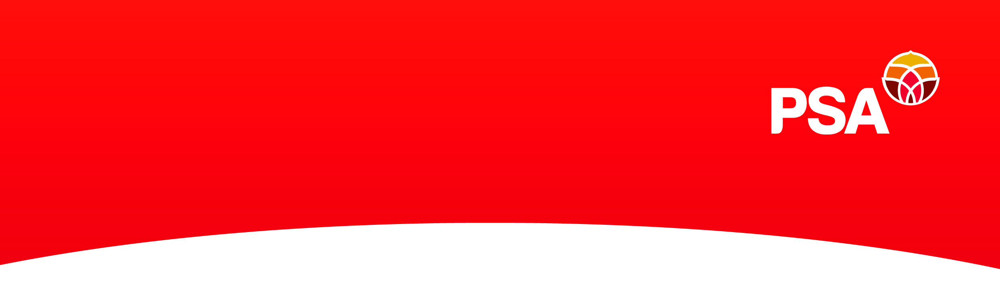

PSA submission to the Finance and Expenditure Select Committee on the 2024 Budget Policy Statement

About the PSA
The New Zealand Public Service Association Te Pūkenga Here Tikanga Mahi (the PSA) is the largest trade union in New Zealand with over 95,000 members. We are a democratic organisation representing members in the public service, the wider public services (including Te Whatu Ora and other crown agents, and other crown entities), state owned enterprises, local government, tertiary education institutions and non-governmental organisations working in the health, social services and community sectors.
The PSA has been advocating for strong, innovative and effective public and community services since our establishment in 1913. People working in public and community services join the PSA to negotiate their terms of employment collectively, to have a voice within their workplace and to have an independent public voice on the quality of public and community services and how they’re delivered.
The PSA is an affiliate of the New Zealand Council of Trade Unions Te Kauae Kaimahi (CTU), Public Services International (PSI) and Uni Global.

PSA response to the Budget Policy Statement
The Budget Policy Statement is a key accountability document for government. New Zealanders should be able to look to the Budget Policy Statement for a clear description from government of the policy reasons for its priorities in the Budget, including where they fit in delivering its long-term vision for the country. That is not the case with the 2024 Budget Policy Statement (BPS). We do not believe it meets the requirements of s26M of the Public Finance Act and we recommend that the Committee refer it back to the Minister of Finance for improvement.

Section 26M of the Public Finance Act specifies that the BPS must state the broad strategic priorities by which the Government will be guided in preparing the Budget for that financial year, including (a) the overarching policy goals that will guide the Government’s Budget decisions; the wellbeing objectives that will guide the Government’s Budget decisions; and (b) the policy areas that the Government will focus on in that year.

The BPS specifies that the Government’s policy goals are to build a stronger, more productive economy, to improve public services especially law and order, health and education, to get the government’s books back in order and restore discipline to public spending. In our view it does not adequately describe how what it is proposing to do will translate into the wellbeing of New Zealanders, and in particular it does not describe how it will do this within the context of the challenges of rising levels of inequality, falling social cohesion, climate change and other environmental concerns.

We believe that the Government’s stated priority of reducing the collective pool of funds available to pay for services and infrastructure, while also increasing the cost to individuals of accessing services and infrastructure will not meet its goal of providing cost of living relief to New Zealanders, but rather exacerbate the many pressures people are under.

The Government’s priority of reducing the baselines of government departments and agencies will reduce New Zealanders’ access to services and support that they need. People rely on public services to be there when they need them. The Government’s approach risks this no longer being the case.

We do not agree that the public service is oversized and that these cuts are justified. It is of similar proportion to the public services of countries we compare ourselves with like Australia and the UK – although in those bigger countries, some of the work our public service does is done by local government, so our public service is actually already doing more with less.

The increase in people working in public services since 2017 has been about rebuilding the skills and capability needed after this was rundown by previous governments, accounting for population growth and dealing with the significant challenges we face including an ageing population, a significant failure of successive administrations to deal with our substantial infrastructure deficit, growing inequality and poverty, lessening social cohesion, climate change and increasingly frequent significant weather events.

The government needs to make sure there’s an open and public evaluation of the impact of the cuts to both jobs and services that will result from their budget priorities. This must include impacts not just on the bottom line but also the ongoing and lifetime costs to individuals and families and their communities, and the impacts on the ongoing ability of the public service workforce to have the skills and experience needed to deliver into the future.

PSA members’ Budget priorities
We included a survey in a regular newsletter to our over 95, 000 members around the country and asked PSA members what they want to see in the Budget. They are clear about what they think the Government’s budget priorities should be.

They want to see a commitment to funding for programmes and services that help families and communities with cost of living, including in particular those with the lowest incomes. There is also strong support for allocating funding to the following (in order of level of support):
- Retaining the school lunches programme
- Reducing the cost of food including through reducing GST on fresh food
- Affordable housing
- Public transport
- Health and education including schools and early childhood education.

They find it unjust that those that earning low or modest incomes from work contribute proportionately more of those incomes in tax than the well off and those earning income from other sources. They do not support cuts to services. They say those services are necessary, in particular community services, education, health and health care including mental health services and housing and public transport. They want agencies to be funded to ensure fair and decent pay rates for people working in public and community services.

They want the Budget to include funding for support and services designed by Māori and delivered by Māori that honour Te Tiriti o Waitangi and empower Māori communities. Healthcare and education are the areas where it’s identified this is most needed and many call in particular for the re-establishment of Te Aka Whai Ora. There is also a strong call for funding to support te reo Māori, in particular at work and in the names of agencies. There is concern about political messages and policies that seek to divide people, rather than bring them together.

Public services create value for our money
The priority set out in the BPS is economic growth and the government assumes wellbeing will trickle down from this, although how this will happen is not described and “trickle-down” economics is an idea that has been discredited, including by the IMF, and is associated with widening inequality. The Budget Policy Statement says the Government is promoting growth through reducing spending on public services and infrastructure that doesn’t contribute to that growth. Economic growth can only be built on a strong foundation which includes the natural environment and public services and infrastructure that supports everyone to thrive. How the planet is doing, how we look after each other – “the economy” is only possible on top of this.

Public services create real value from the funds we all pool to pay for them. The work people in public and community services do every day creates this real value we all rely on. In using our shared resources for public services we’re building up all of our strengths as a country. Without this strong foundation, we’re building on sand.

New Zealand can use our powerful public dollar to create real value for our money. PSA members want a country where our natural environment is able to continue to support us. PSA members think it’s fair if everyone has a secure and healthy place to live and access to clean water and good food. We want everyone to have access to the healthcare and other care they need, when they need it. We want all of our kids to have a chance at a good education and opportunities to grow their skills and experiences. We want everyone to be able to participate in the life of their communities and for our cultures to thrive. We want all of our communities to be safe and for everyone to have a fair go. This is the value the work of people in public and community services creates.

At the moment in Aotearoa, our relative peace and prosperity is not shared equitably. We all pay the price. Sure it costs to fix this, but it costs us all more not to. We’ve got to build the future we want by building on all of our strengths, and that means getting real value for money by using the power of our public dollar. New Zealand is in the rarefied group of 20 countries with the lowest borrowing costs. We can be what we want to be. We need a Budget that creates the most real value for our public dollar and builds our strengths through funding the public services, care and infrastructure we need.

For further information, please contact:

Kirsten Windelov
Senior Advisor
Policy and Strategy
New Zealand Public Service Association
PO Box 3817
Wellington 6140

Phone: 027 213 7184
Email: kirsten.windelov@psa.org.nz

