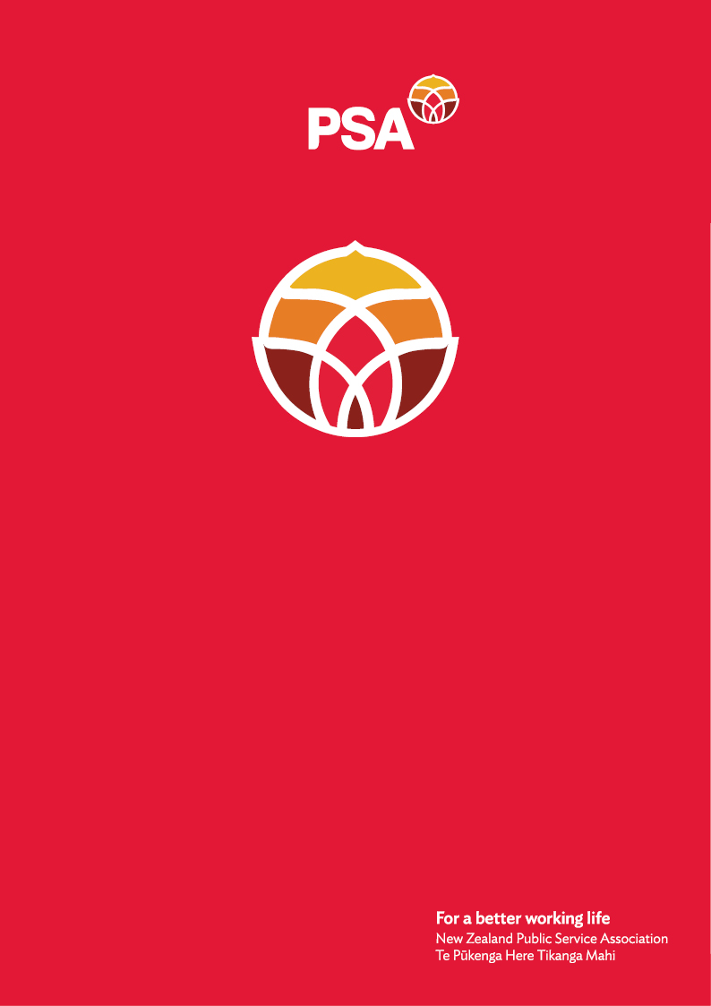

**PSA Submission of the**

**PSAY Network**

**On the**

**Employment Relations (Pay Deductions for Partial Strikes) Amendment Bill**

January 2025

## Introduction

The New Zealand Public Service Association Te Pūkenga Here Tikanga Mahi (the PSA) is the largest trade union in New Zealand with over 96,000 members. We are a democratic organisation representing members in the public service, the wider state sector, local government and non-governmental organisations working in the health, social services and community sectors.

## Who is the PSAY?

PSA Youth (PSAY) is the largest youth union network in Aotearoa, representing 27,000 young workers under 35 across all sectors of the public service. We advocate for fair wages, secure employment, and equitable workplace conditions for young workers. As the future of the union, we understand the value of collective bargaining in shaping fair workplaces. Our work is rooted in equity, social justice, and ensuring young voices shape the future of work in Aotearoa.

## Why We Oppose the Bill:

When in collective bargaining, section 32 of the Employment Relations Act 2000 mandates that employers and unions act in good faith when negotiating new terms of a collective agreement.

Industrial action, including work-to-rule, co-ordinated breaking and strikes, has long been an important tool in negotiating collective agreements, where discussion between parties and externally mediated negotiations have failed. So long as the relevant legislation is followed in relation to strike action, the right to lawful strike action is protected by law. The relevant Act provides actions that the employer may use in response to industrial action – including suspension of employment and lock outs. While we do not agree with these, these actions already exist and may be used by the employer.

The Employment Relations (Pay Deductions for Partial Strikes) Amendment Bill punishes workers for lawful action. It lets employers cut 10% of wages, even when work is still being done, without proof of reduced output. Deductions could even push wages below the legal minimum. For young workers in entry-level roles, this is a serious financial hit which can deepen hardship for workers.

We already face financial strain as our wages struggle to keep up with inflation. Many New Zealanders earn below the living wage and have limited job security, Stats NZ 2024 data show that this wage discrepancy is especially visible for workers aged under 25 years old. Penalising (young) workers instead of addressing workplace issues in good faith is not the answer.

## Why This Matters for Young Workers:

Young workers already face financial strain, often balancing part-time jobs, study, and rising living costs. Despite these challenges, we must be able to speak out against unfair conditions—whether it's lack of proper breaks or understaffing. Our colleagues aged 15–24 years old make up a large part of the workforce, particularly in entry-level roles, and would be hit hardest by this Bill. Many of us are just getting by, yet this Bill punishes us for taking lawful action to improve our conditions and those who are about to enter the workforce. No New Zealander should be penalised for standing up for their rights to have a fair working environment.

## Conclusion:

We cannot afford to be penalised for standing together and fighting for better working conditions. The Employment Relations (Pay Deductions for Partial Strikes) Amendment Bill is unfair, and it disproportionately impacts young workers who are already facing financial struggles. In short, we believe this bill undermines and attacks unions. It makes it more difficult for workers, especially young workers, to utilise their rights under employment law and stand up for fairer pay and better working condition.

Where workers are still fulfilling their duties, there is nothing to justify reducing their pay. Rather than financially penalising those standing up for their rights, we believe there should be a focus on good-faith negotiations to prevent things getting to the stage of industrial action. Allowing for pay reductions in the event of a partial strike action is an ambulance at the bottom of the cliff for the employer and would highlight and exacerbate the critical power imbalance that exists between employers and young workers.

Frankly, this Bill is akin to pouring salt into the wound of young workers. We seek protection for young workers, whether we’re in full-time or part-time roles, studying or living at home, so we can continue to advocate for fair pay and conditions without risking financial hardship.

We strongly urge the committee to reject this Bill and protect the rights of young workers.

For further information, please contact:

Andrea Fromm

Senior Advisor, Policy and Strategy

New Zealand Public Service Association (PSA) Tē Pūkenga Here Tikanga Mahi

PO Box 3817, Wellington 6140

Mobile: 027 5816170 | Email: [andrea.fromm@psa.org.nz](mailto:andrea.fromm@psa.org.nz)